DIGITAL GEOSCIENCES: E-JOURNAL OF INTERACTIVE ON-LINE MAPS
G. Origel-Gutierrez¹, L. Ferrari², J. Lopez-Blanco³
1 - Programa de Posgrado en Geografía / Centro de Geociencias, Universidad Nacional Autónoma de México, Campus Juriquilla, Querétaro, Qro. México, C.P. 76230. E-mail: gorigel@geociencias.unam.mx
2 - Centro de Geociencias, Universidad Nacional Autónoma de México, Campus Juriquilla, Querétaro, Qro. México, C.P. 76230. E-mail: luca@geociencias.unam.mx
3 - Instituto de Geografía, Universidad Nacional Autónoma de México, México D.F. 04510. E-mail: jlopezblanco@hotmail.com

Abstract
The Universidad Nacional Autónoma de México (UNAM), through its Centre for Geosciences and institutes of Geography, Geophysics and Geology, has created an electronic publication called Digital Geosciences, which is an e-only journal with international perspective specializes in the web publication of Earth Science and Physical Geography cartography (e-maps). This e-journal is the main result of a research project analysing the scientific role of the cartography especially in the publication, communication and dissemination of geoscientific maps. The journal’s proposal considers the cartography value and its scientific role in data capture, integration, synthesis and representation. The purpose of this journal is to facilitate the distribution of online cartographic products using the most recent Internet and mapping technologies as well as to rescue the value of cartography and its recognition as scientific product. Digital Geosciences publishes peer-reviewed GIS-based maps from any part of the world although Latin America is the main region of interest. Official languages are Spanish and English. This e-journal is presented as an alternative to publish and disseminate geoscientific cartography. We present e-journal conception and development, operational details and information for international contributions with the emphasis in the web mapping publication (adaptations, modifications and changes). Scientific reviewers evaluate all cartographic contributions and maps accepted are published using a system integrated with Apache Web Server, Tomcat, ESRI's ArcIMS Internet Map Server and ArcMap Server extension. Map Server interface was implementing using standard ArcIMS pre-designed output with some simple adaptations and settings. A special feature of the journal is the creation of spatial data and metadata bases. So, only GIS-based map can be submitted. Comparing with printed media, the GIS-based on-line maps have major possibilities for distribution, they are more economic and easier for up to date. The first map published was the Geologic map of Sonora, Mexico at scale 1:1,000,000 (González-León et al., 2006). It is mainly a compilation work that includes the most updated geologic information of that State. This document is now available at the website http://digitalgeosciences.unam.mx. Critical web mapping adaptations for this map were the integration of colours standards, patters to fill polygons, geological symbols design and layer visualisation according to scale. We are working in the implementation of Map Server free software, Image Web Server, GeoNetwork metadata web based catalog, and the full integration of on-line peer-review process including map notes and map edition capabilities.

1. INTRODUCTION

Maps and other cartographic products are traditionally considered an excellent and powerful medium to integrate, communicate, visualize, present and analyse spatial data and information. According to Smith (2006), in the late 19th and early 20th centuries, map production underwent a widespread academic uptake, which was associated with the expansion of geographic and geological research. At that time, map publication was the primary result of a geology article, whereas the discussion was included for secondary purposes. Now, the situation has dramatically changed. Mapping is still a common and basic practice in Geosciences, but map publication as a scientific product has declined.

Today, geomatics technology is frequently used to support geoscientific research. In particular, Geographical Information Systems (GIS) are often applied to carry out spatial analyses and to find spatial trends. Digitising, data integration, map design and print function are increasingly done using GIS software.

Map production continues as a basic practice in geoscientific research. Consequently, it is necessary to find alternative ways to publish them.

According to Peterson (2005), maps represent one of the main web searches. The largest Internet corporations have developed applications such as Google Map, Google Earth and Microsoft Digital Earth, resulting in the ever-increasing presence of maps in daily life (Taylor and Caquard, 2006; Goodchild, 2005).

Even though many websites publish interactive online cartography, very few maps are scientifically and technically reviewed. The interactive functions in these websites are often limited to zooming and panning, identifying features and printing from the visualized part of the map. It is also common to find several cartographic products using erroneously some critical design elements of the maps, such as the bar scale and geographic grid (Origel-Gutiérrez, 2004).

Consequently, it is necessary to develop new Web Mapping Services especially adapted and designed for this communication medium, integrating cartographic concepts and principles with web functionality and user-oriented design. Supporting the peer-review process is critical for the scientific validation of web cartographic products.

2. JOURNAL DIGITAL GEOSCIENCES

The Universidad Nacional Autónoma de México (UNAM), through its Centre for Geosciences and institutes of Geography, Geophysics and Geology, has created an electronic publication called Digital Geosciences, which specializes in the web publication of Earth Science and Physical Geography cartography. The purpose of this journal is to facilitate the distribution of online cartographic products using the most recent Internet and mapping technologies, as well as to rescue the value of cartography and its recognition as a scientific product. Digital Geosciences publishes peer-reviewed GIS-based maps and proposes a new paradigm for the elaboration of cartography: To create geoscientific cartographic documents from spatial databases for their web publication, integrating interactive functions, adapted to user requirements, and respecting guidelines that assure the quality of the spatial databases. It can thus serve as an alternative medium to publish and disseminate cartographic products.

Digital Geosciences was conceived as a means to re-establish the scientific value of cartography, recognizing that it requires considerable effort in terms of the collection, integration, synthesis, generalization and representation of data. It responds to the need to create an academic space and forum to publish refereed research-based cartographic products. Maps are considered true scientific documents and given a central role. To achieve this goal, maps must be peer-reviewed and once accepted they may reach a large number of potential users by using new, cost-effective means through the Internet. Consequently they will have a larger geographical distribution and greater academic impact.

In the conceptualisation of Digital Geosciences, three decisions were critical: web publication, interactive functionality, and map production using spatial databases. These special features are included among the elements identified in the new cartographic paradigm called cybercartography (Taylor et al., 2005; Taylor and Caquard, 2006).

This international scientific journal will publish maps from any part of the world, although Latin America is the main region of interest. The official languages are Spanish and English, and the use of both is mandatory in abstracts and legend descriptions. We plan to publish six interactive maps per year (one map every two months). The periodicity will be managed as yearly only to report the production and to be evaluated as a scientific journal. As soon as possible we will increase our capacity for interactive map publication. Indexation will be possible after the first two years considering the period needed for the evaluation process.

Contributions to Digital Geosciences may fall into these types of documents:

- Original and unpublished GIS-based maps or spatial data.
- Reinterpretation of cartographic products or data, which were created or collected by the same or other authors, and reported in documents that had a limited circulation, were not published or were not formally edited, such as professional or postgraduate theses and internal technical reports. In this case it is necessary to specify the cartographic contribution and the criteria used in the reinterpretation.
- Documents as in b) already published in printed or digital format. A letter will be required from the copyright owner authorizing a new digital publication. In this case it is necessary to specify the cartographic contribution and the criteria used in the reinterpretation.
- Compilation from several cartographic documents or data (printed or electronic), systematically integrated into a spatial database with the relative attributes (coordinates, measurements, references, methods).
- Updated version of maps already published in printed format by the same or other authors. A letter will be required from the editor or copyright owner authorizing a new digital publication.

2.1 Geomatics Model

The cartographic production implemented in Digital Geosciences is carried out from spatial databases and their associated metadata, utilizing GIS and other geomatics software, standards and specifications, databases management systems, Web Mapping Servers, Web Servers and web design techniques centred on the user (Figure 1). In this way, users can know the characteristics of published material, permitting the flux of very diverse information in simultaneous form and the intuitive exploration from the web browser and other spatial data viewers.

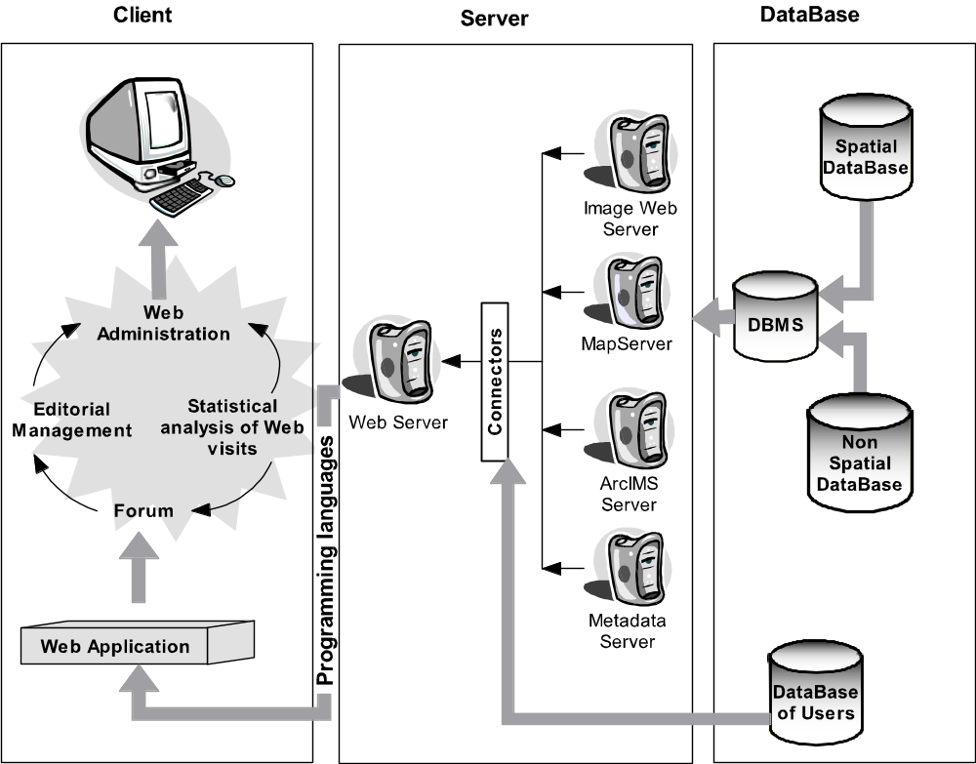
Figure 1. Geomatics model for cartographic production in Digital Geosciences.
Digital Geosciences adopted an Information Model for its web map production to describe the database requirements for map-making from GIS data (Figure 2). This model is “a top-down approach that starts with the purpose and audience for the map which led to map conceptualisation, then it defines the data requirements, and finally allows the specification of the process model for map production” (Buckley et al., 2005). The “model is derived from a communication model that compasses traditional cartographic design and production processes to transform geographic data to a map product” (Buckley et al., 2005).

The criteria used to choose this model were the easy adaptation for the online map production process and the full support for this process using ArcGIS software, which is a critical part of the architecture of the Web Mapping Production System implemented in the journal.

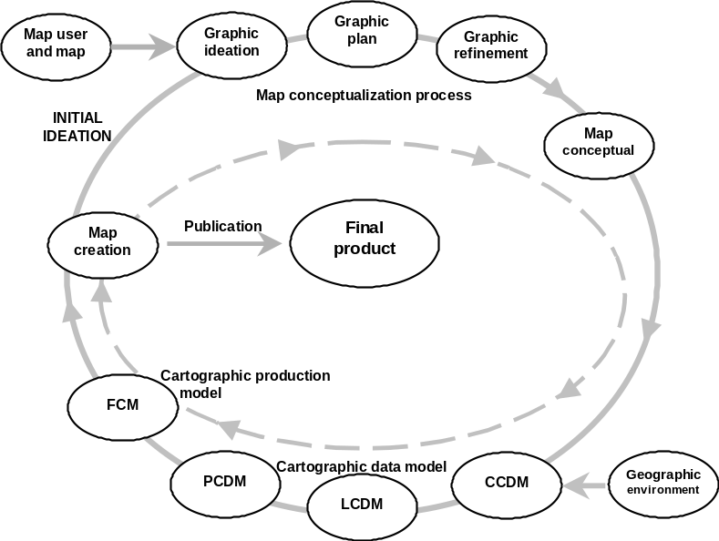

Figure 2. Information Model used in the cartographic production from GIS databases (after Buckley et al., 2005). Cartographic Data Model (CDM) details: Geographic environment is transformed to a Conceptual (C) CDM, then to a Logical (L) CDM and finally to a Physical (P) CDM. The resulting data model is used with a Functional Cartographic Model (FCM).

2.2. Architecture of the Web Mapping Production System

The system implemented in Digital Geosciences is integrated by one Linux server (Ubuntu Server Edition) with two Opteron 64 bits processors (4 GB RAM and 380 GB HD). It works as an Apache + Tomcat Web Server and “Dual Map Server” (ArcIMS commercial and Map Server free software). In addition, a Windows XP “Dual Map Server” with Intel Pentium IV processor (2 GB RAM and 200 GB HD) is available.

Spatial databases are in ESRI Shape file vector format. They are described using a metadata standards FGDC (FGDC, 2000) or ISO/TC211 19115. The ESRI ArcIMS software is used to develop mapping service applications for the Web, while the ESRI ArcMap Server extension for ArcIMS and ArcGIS with Maplex extension for automated text placement and cartographic design are used in the creation of complex design maps. The Web Mapping Services are generated for HTML viewers integrating the Web Map Service (WMS) Implementation Specification of OpenGIS Specification (OGC, 2006).

Among other software included are My SQL (dynamic website using database access), PHP 5 and Perl (languages to develop server applications), Postgree SQL (object-relational database system), PostGIS (extension to the Postgree SQL that allows GIS objects to be stored in the database), Awstats (statistics analyser using web logs), Open Journal System (Editorial Management System) and GeoNetwork (a Web based Geographic Metadata Catalog System).

2.3. Website and Map Viewer

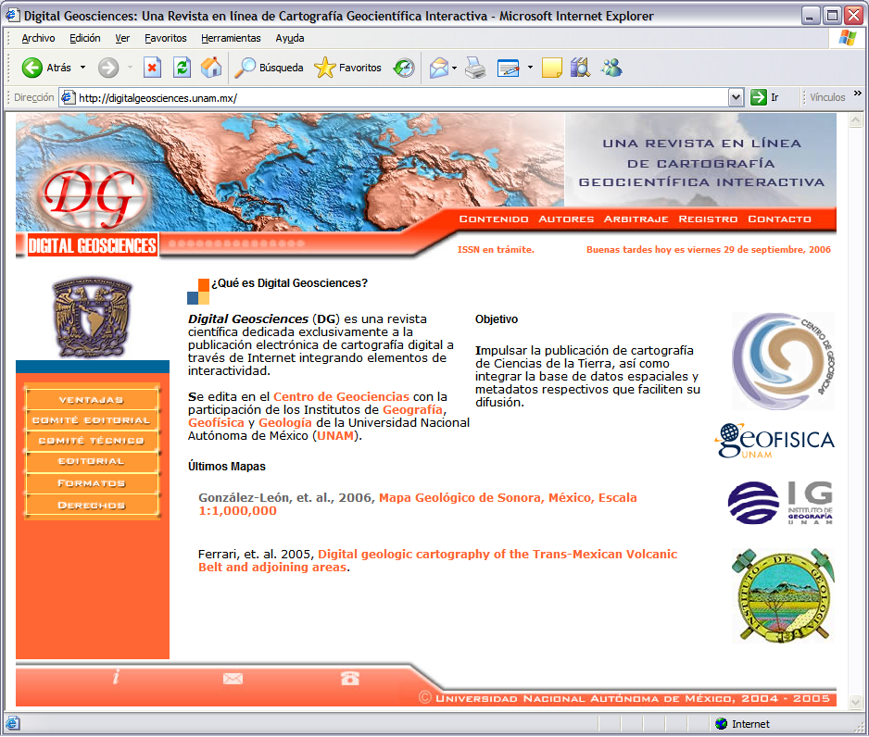
Figure 3. First Spanish version of the Digital Geosciences website http://digitalgeosciences.unam.mx
The Digital Geosciences website was designed considering user oriented criteria and usability. Initially created only in Spanish (Figure 3), it is now also available in English using Open Journal System for greater international exposure of our new map journal.

Basic tools in the Map Viewer integrate the following interactive functions: toggle between legend and layer list, toggle overview map, zoom in, zoom out, zoom to full extent, zoom to active layer, zoom previous, panning, pan to north, pan to south, pan to east, pan to west, identify, find, measure, set units, clear section and print view (Figure 4).

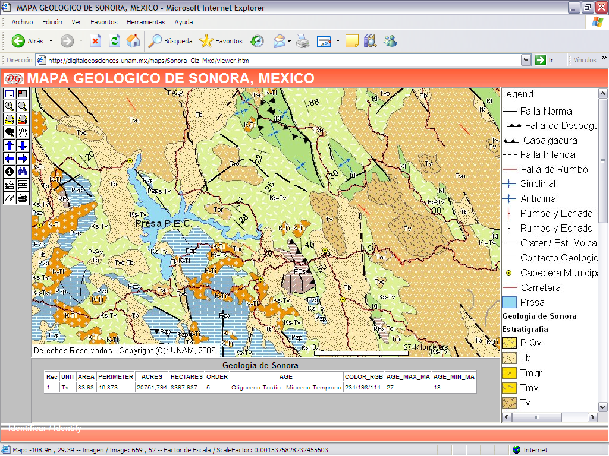
Figure 4. Digital Geosciences Map Viewer showing a geologic map powered by the ArcIMS and ArcMap Server extension.

2.4. Examples of published maps

Recently, Digital Geosciences published its first map (see Figure 4). This geologic map (scale 1:1,000,000) of Sonora, Mexico (González-León et al., 2006), is mainly a compilation work that includes the most updated geological information of that state. An important part of the information came from recent geologic cartography published by the Consejo de Recursos Minerales (now Servicio Geológico Mexicano). The rest was extracted from scientific articles, graduate and doctoral theses, databases generated by the authors, as well as unpublished information. This map is the result of an interpretation of the above information and other structural aspects. The map distinguishes 34 lithologic divisions, including the main lithostratigraphic units and age (from isotopic ages inferred from the stratigraphy), and the tectonic setting of deposit.

3. TECHNICAL NORMS

Technical norms regarding formats and minimum parameters of uniformity for the material accepted have been established to facilitate the review process and web publication. Following these norms reduces the time needed for the production of maps.

First, authors will have to complete the format for the submission of cartographic contributions, indicating the basic information needed to identify the cartographic documents, as well as metadata related to the final document and its layers of spatial data. We considered the critical metadata categories indicated by Kim (1999) because their use allows simplifying the description of the most important metadata items. The reference system of projected coordinates will be reported in metadata using the numerical code implemented by the European Petroleum Survey Group (2004).

After that, authors have to send an image (raster format, Table 1) of the map submitted, including a proposal for the cartographic design.

Table 1. Accepted Raster Formats
1. Geo Tag Image File Format (GeoTIFF) with 256 colours (8-bit colour table) using LZW compression.
2. Tag Image File Format (TIFF) with 256 colours (8-bit colour table) using LZW compression; TFW world file is required.
3. Portable Network Graphics (PNG), with 256 colours; PGW world file is required.
4. JPEG (JPG + JGW).
5. ECW+ERS, MirSID, JPEG 2000 (only for maps using aerial photography or satellite images).

The technical editor will indicate the suitable vector format listed in preference order (Table 2), based on the type of document to be published, the methodology and the software used. Vector files should include the corresponding topology (networks, polygons). In the case of polygons the minimum mapping area will be based on the scale of the cartographic bases (Table 3).

Table 2. Vector Formats
1. Shape File from ESRI ArcView or ArcGIS (including SHP, DBF, SHX and PRJ files)
2. E00 ArcINFO ESRI without compression
3. ArcGIS Geodata base
4. Geographic Markup Language (GML) / GeosciML (Bellier, C., et al., 2006)
5. DXF 12

Table 3. Minimum Mapping Area
Cartographic Scale |  | Minimum Mapping  Area (cm²)
4,000,000 |  | 1
1,000,000 |  | 1
250,000 |  | 1
50,000 |  | 0.4
20,000 |  | 0.25
>20,000 |  | 0.25

The cartographic compilations or re-interpretations will have to add a vector file (Table 2) containing the areas covered by previous maps and the corresponding credits and references.

The formal or informal character of a lithostratigraphic unit on the geologic maps will be denoted according to the international perspective of Digital Geosciences, following the criteria established in the Stratigraphic Code of Nomenclature (NACSN, 1983), Stratigraphic Guide (ISSC, 1994) and International Stratigraphic Chart (ICS, 2004).

The legend of the geologic maps will be created as a table or database using the following fields: consecutive identifier of the stratigraphy in ascending sequence from the most recent lithostratigrafic unit to the oldest, key level for the unit, full name of the unit, oldest stage or period, most recent stage or period, oldest age in Ma, most recent age in Ma, geological group, formation, detailed description of the unit, bibliographical references to the unit (author, year) and colour code (R/G/B) for the unit according to the Commission for the Geological Map of the World. Optionally, other fields may be added if the information is available.

We recommend that the geologic maps integrate an image with the graph of the stratigraphic column, and at least a cross-section using one of the formats given in Table 1. For the cross-sections and profiles, a vector file has to be added including the location on the cartography using one of the Table 2 formats.

The information about geological structure measurements will be stored in Excel or DBF formats, including the following data: X coordinate, Y coordinate and azimuthal direction (0-360).

The size of the final files can be reduced using RAR, ZIP or TAR compression for electronic sending. More details regarding technical norms are available in Origel-Gutiérrez et al. (2006) and the Digital Geosciences website.

4. EDITORIAL PROCESS AND PEER REVISION

The editorial process (Figure 5) consists of two stages. The contributions submitted for possible publication will first undergo a technical review, which will evaluate the integrity and fulfilment of the minimum requirements according to the technical norms. Once this revision is passed, the contributions will then be subjected to a scientific review, carried out by peers selected by the Editor-in-Chief in coordination with the members of the Editorial Board. The authors may propose the name of potential referees who may provide an unbiased review and have no conflict of interest with the author.

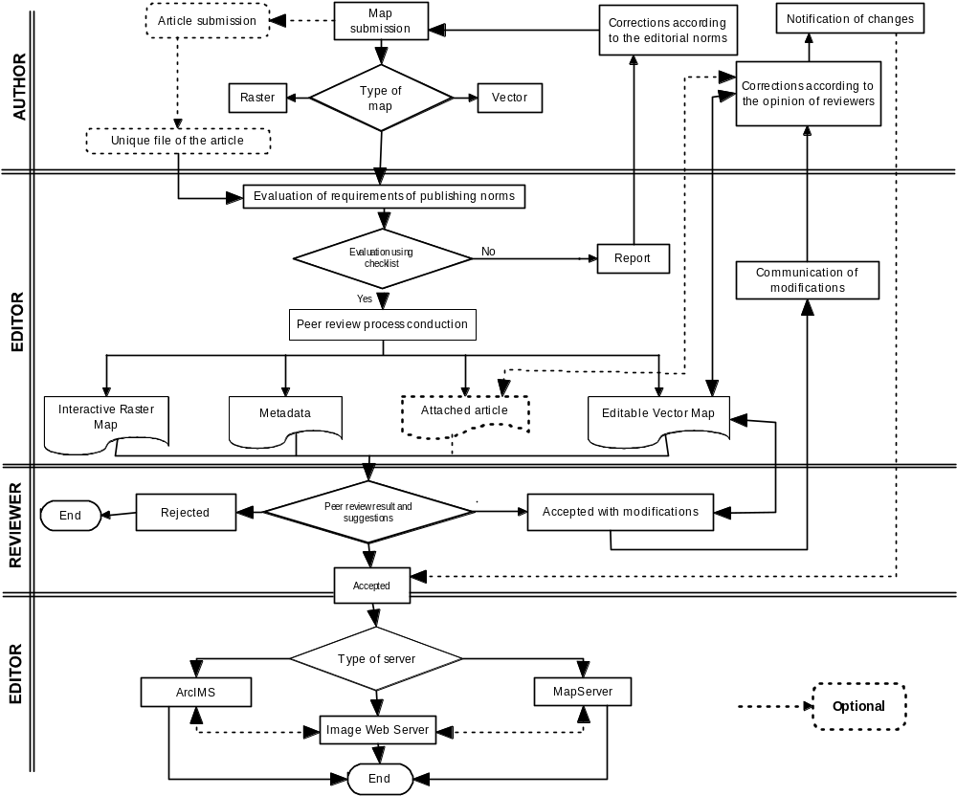
Figure 5. Editorial process used in Digital Geosciences.

After checking the digital map to assure that it meets the technical norms, the submitted product is passed to the scientific editor. The purpose of the scientific review is to guarantee the quality of the information provided by the map, the internal consistency of the digital product, and the reliability of the data presented. The digital map will normally be sent to at least two reviewers, who preferably should be familiar with the study region or with the relevant literature on the subject. Alternatively, a good knowledge of the kind of geologic terrain portrayed in the map is required.

5. CONCLUDING REMARKS

Map production is an essential part of geoscientific research, and through the publication of Digital Geosciences we aim to provide a specialized medium to communicate this kind of scientific work. This journal represents an alternative for publishing and disseminating geoscientific cartographic products across the Web. Online maps offer many distribution possibilities, their production is economical and they are easily updated. The Map Interface is designed to provide tools that transform the map with interactive functionality. The peer-review process and the multi-institutional integration of the Editorial Board are steps toward attaining recognition and the inclusion of the journal in international indexes.

We are working on the full implementation of Map Server free software and open platform to develop and try new user functions and customisation. We also plan to install a GeoNetwork (a Web based Geographic Metadata Catalog System) to recover previously published maps and spatial data bases used in the map creation. Finally, we are working on the full integration of the online peer-review process using the free Open Journal System software adapted to work with maps, integrating Map Server functions for map notes and map edition.

6. ACKNOWLEDGMENTS

The graduate study grant program of the Mexican Government (Consejo Nacional de Ciencia y Tecnología, CONACYT) is gratefully acknowledged. We thank Sara Solís Valdez, Minerva Durán Martínez and Irma Arriaga Palma for their support in the implementation of the journal’s computational system, Map Server adaptation and web map production.

7. REFERENCES

- Bellier, C., Robida, F., Serrano, J. J., Brodaric, B., Boisvert, E., Richard, S., Johnson, B., Laxton, J., Duffy, T., Sen, M., Simons, B., Ritchie, A., Wyborn, L., Cox, S., Stolen, L., (2006). GeosciML, the Geosciences Markup Language, Extended Abstracts of the III International Conference GIS in Geology, Moscow: Rossian-French Metallogenic Laboratory, 16-17.
- Buckley, A., Frye, C. & Buttenfield, B., (2005). An information model for maps: Towards cartographic production from GIS databases. Proceedings of the 22nd International Cartographic Conference [CD ROM], 9-16 July, A Coruna, Spain.
- European Petroleum Survey Group (EPSG) (2004). EPSG Geodetic Parameters [on-line], European Petroleum Survey Group <http://www.epsg.org/Geodetic.html> [Consulted: October 17, 2006].
- Federal Geographic Data Committee (FGDC) (2000). Content Standard for Digital Geospatial Metadata Workbook Version 2.0 (for use with FGDC-STD-001-1998), Federal Geographic Data Committee, USA, 122 p.
- Ferrari, L., Rosas-Elguera, J., Carrasco-Nuñez, G., Orozco-Esquivel, M.T. & Cortez-Norato, T., (in press). Digital geologic cartography of the Trans-Mexican Volcanic Belt and adjoining areas.
- González-León, C.M., Valencia-Moreno, M.A., Noguéz-Alcántara, B. & Salvatierra-Domínguez, E. (2006). Mapa Geológico de Sonora, México escala 1:1000,000 [on-line], Digital Geosciences, UNAM, México. <http://digitalgeosciences.unam.mx/maps/Sonora_Glz_Mxd/viewer.htm> [Consulted: October 17, 2006].
- Goodchild, M., (2005). What does Google Earth Mean for the Spatial Sciences? Biennial Conference of the Spatial Sciences Institute, 12-16 September, Melbourne, Australia.
- International Cartographic Association (ICA) (2004). Proceedings of the First International Joint Workshop on Ubiquitous, Pervasive and Internet Mapping (UPIMap 2004, Tokyo, September 7-9). Tokyo: International Cartographic Association, 193 p.
- International Commission on Stratigraphy (ICS) (2004) International Stratigraphic Chart (on-line): International Union of Geological Sciences, International Commission on Stratigraphy <http://www.stratigraphy.org/chus.pdf> [Consulted: October 17, 2006].
- International Subcommission on Stratigraphic Classification (ISSC) (1994). International Stratigraphic Guide –An abridged version (Amos S., Murphy, M.A. eds.), [on line]: International Subcommission on Stratigraphic Classification of the International Union of Geological Sciences, International Commission on Stratigraphy, <http://www.stratigraphy.org/guide.htm> [Consulted: October 17, 2006].
- Kim, T.J. (1999). Metadata for geo-spatial data sharing: Acomparative analysis, The Annals of Regional Science, Springer-Verlag, 33, 171-181.
- Kraak, M.J. (2001). Trends in cartography. In Kraak, M.J. & Brown, A. (eds.), Web cartography: Developments and prospects, 9-19, London: Taylor & Francis.
- Kraak, M.J., Brown, A. (eds.), (2001). Web cartography: Developments and prospects, London: Taylor & Francis, 213 p.
- Mackenzie, O.J. (2006). The Scientific Article in the Age of Digitization, Series: Information Science and Knowledge Management, Vol. 11, XII, Springer, 265 p.
- Open Geospatial Consortium (OGC)(2006). OpenGIS Web Map Server Implementation Specification [on line], version: 1.3.0, reference number: OGC 06-042 <http://www.opengeospatial.org/standards/wms> [Consulted: October 17, 2006].
- Origel-Gutiérrez, G. (2004). Layout and Design elements in the quality estimation of bi-dimensional Internet based mapping. In International Cartographic Association (ICA). Proceedings of the First International Joint Workshop on Ubiquitous, Pervasive and Internet Mapping (UPIMap 2004, Tokyo, September 7-9), 132-139, Tokyo: ICA.
- Origel-Gutiérrez G, Cabral-Cano, E., (2004). La calidad técnica en la cartografía sobre la Faja Volcánica Mexicana: Un análisis en tesis y publicaciones de geociencias de la UNAM para el periodo 1980-2000, Revista Mexicana de Ciencias Geológicas. 21(2), 285-298.
- Origel-Gutiérrez, G., López-Blanco, J. & Ferrari, L. (2006). Normas técnicas preliminares para la publicación de cartografía interactiva en páginas web: El caso de la Revista Electrónica Digital Geosciences en México, XII Simposio SELPER International [CD ROM], Sociedad Latinoamericana de Percepción Remota y Sistemas de Información Espacial [Cartagena de Indias], Colombia [Proceedings of Symposium].
- North American Commission on Stratigraphic Nomenclature (NACSN) (1983). North American Stratigraphic Code [on line], The North American Commission on Stratigraphic Nomenclature, <http://www.agiweb.org/nacsn/code2.html/>, [Revised June 2003 from July 1983 Reprint] [Consulted: October 17, 2006].
- Peng, Z.R., Tsou, M.H., (2003). Internet GIS: Distributed Geographic Information Services for the Internet and Wireless Network, John Wiley & Sons. 720 p.
- Peterson, M.P. (2005). A Decade of Maps and the Internet. Proceedings of the 22nd International Cartographic Conference [CD ROM], 9-16 July, A Coruna, Spain.
- Peterson, M.P., (ed.), (2003). Maps and the Internet, Cambridge: Elsevier Scientific Press, 468 p.
- Smith, M.J. (2004). The Journal of Maps: An electronic journal for the presentation and dissemination of map based data, Geography. 89, 298-299.
- Smith, M.J. (2006). The Journal of Maps: Rationale for Its Establishment and Review of Initial Operations. The Cartographic journal. 43(1), 90-96.
- Taylor, D.R.F. & Caquard, S. (2006). Cybercartography: Maps and Mapping in the Information Era. Cartographica, 41(1), 1-5.
- Taylor, D.R.F., Eddy, B., Pulsifer, P., & Lauriault, T. (2005). Cybercartography: Theory and practice, Proceedings of the 22nd International Cartographic Conference [CD ROM], 9-16 July, A Coruna, Spain.
- Verstappen, H.Th. & van Zuidam R.A. (1991), The ITC System of Geomorphologic Survey: A basis for the evaluation of natural resources and hazards, ITC Publication Number 10, Enschede: ITC, 89 p.

